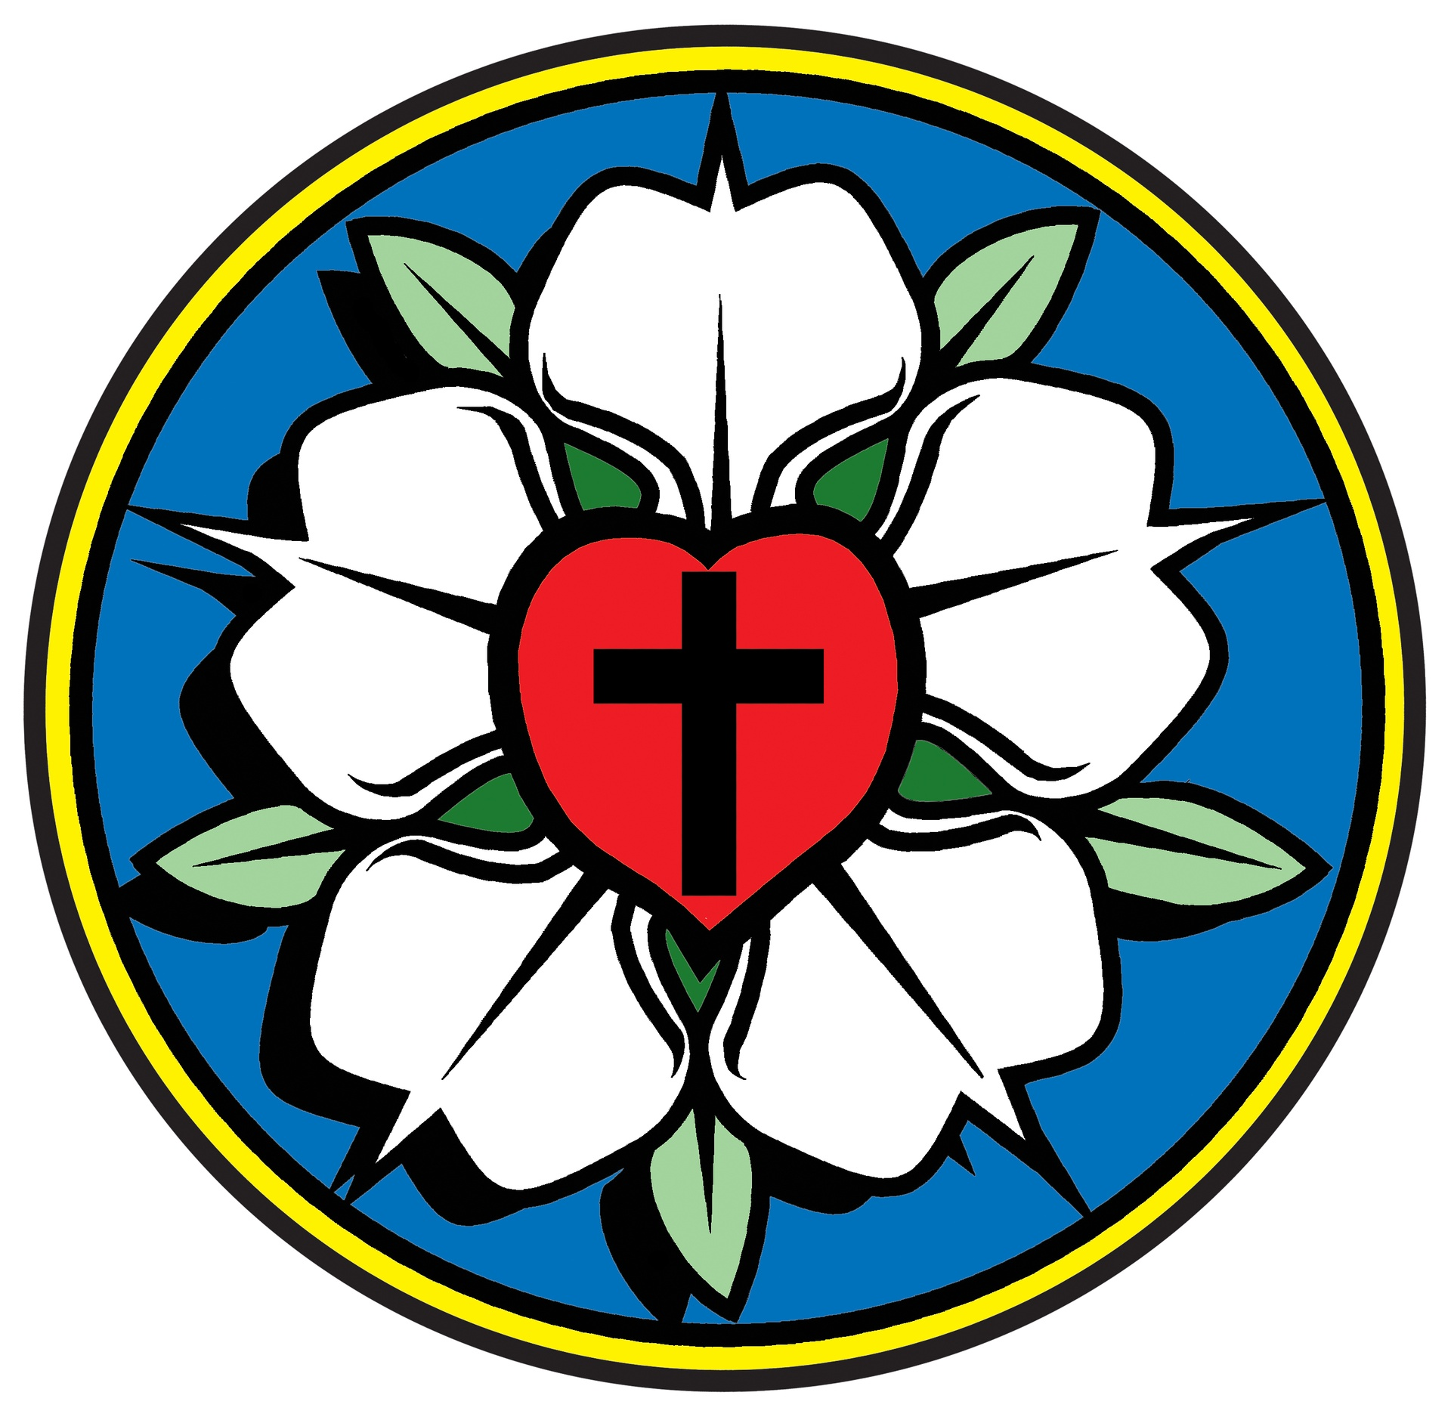
Reformation Lutheran Church
“Come and See, Learn and Rejoice, Go and Tell!”
September 2026

*********************************************************************************************************
“…let the wicked forsake his way, and the unrighteous man his thoughts; let him return to the Lord, that he may have compassion on him, and to our God, for he will abundantly pardon.”
- Isaiah 55:7 -
Did it ever occur to you how much our sense of fairness is at odds with God’s mercy? The prophet Isaiah calls upon the wicked to repent. No matter what the person’s past, there is hope that comes from God who is compassionate and willing to not only pardon, but abundantly pardon. This is certainly good news. In many respects, such repentant individuals are not unlike the people who were invited to work in the vineyard in the last hours of the day.
Matthew 20:1-14 is a parable from Jesus about workers called by a master to work in his vineyard. At the break of day, the first workers agree with the master about the wage for their work. As the day goes on, the master employs more workers. Even as the end of the day approaches, more people are hired (vs. 7). Finally, the day is over, and it is time to receive payment.
The people hired at the end of the day receive the same payment as those hired at the very beginning. Those hired at the beginning of the day cry “unfair”. “…These last worked only one hour, and you have made them equal to us who have borne the burden of the day and the scorching heat.” (vs. 12).
Yes, the same people who come to Jesus late in life will receive the same grace as those of us received when we were baptized as infants. They may never have sat through two years of confirmation, attended council meetings, tithed, served the church suppers, chaperoned youth group trips, helped with Vacation Bible school, or some of the many things we expect from church volunteers.
God’s grace is simply that, grace! “Am I not allowed to do what I choose with what belongs to me? Or would you begrudge my generosity?” (Vs. 15). As God’s children we are not called to insist on the world’s level of faithfulness. Afterall, God has also dealt with us in a generously grace filled way.
Heavenly Father, make our hearts sincere in praying for the return of the wicked and grant us the courage to extend the forgiveness you have shown us. In Jesus’ name. Amen.
Pr.
**************************************************************************************************************
President’s Message: Tuesday will be the first of September. You might say it’s just another month or fall is coming or it’s time for college football. But September is special. September is Back To Church month and Back To Church Sunday is September 20. What a great time to reach out to friends, relatives, and neighbors and invite them to church.
We have been holding firm with around 15 people attending each Sunday. That’s fine, but wouldn’t it be great to have 20 or 25 each Sunday? What about 30??? Jesus gave all of us a challenge…go and make disciples. Let’s accept the challenge and build Reformation Lutheran Church. Back to Church Sunday would be a great start!

Property: Clean-up day is scheduled for Saturday, September 26th. Helping hands are always welcome!

Education: Our Bible Study continues each Sunday at 9:30. Everyone is welcome!

Worship and Music: The new music program is up and running. So far, so good! I personally enjoy the Amen at the end of each hymn. Thanks again to Amy and Wayne for getting things going.
Fellowship: The men are continuing to enjoy their lunches together every 2nd Thursday of each month. The women do not have anything on the calendar for September, but let’s keep talking about it and try to schedule a brunch or lunch. We do not have any September birthdays to celebrate but there are a few in October to look forward to!
Another gathering to look forward to in October is Reformation Sunday, October 25th, when we organize our annual German potluck after service! Remember to put it on your calendar!

Mission and Ministry: Everybody enjoyed a very informative evening this past month when we hosted Inspector Alton Weeks and his partner Ryan with Harris County Sheriff’s Department to present their Fraud and Scam Prevention Program.
Join the Rammings on Monday, September 14, 9:00 a.m. at FOCUS Food Pantry for delivery to be made and to help with unloading and stocking shelves.
September 20th is “Back to Church” Sunday! Chuck Hunsaker is placing an article in the Harris County Journal to inform readers about Reformation. Don’t miss your opportunity to invite a friend or family member to join us for worship!!
Also, this month we will have the AARP Drivers Safety Class on September 22, 9:00 a.m. - 4:00 p.m. Cost is $20 if you are an AARP member and $25 if you are not an AARP member. Bring your membership card, driver’s license, snacks and a pen. Make checks payable to AARP. Registration is required. Call (706) 478-7077 to register. Leave a message with your name, phone number, and how many will be attending. They will return your call.

*************************************************************************************
Sept.6 Sept. 13 Sept. 20 Sept. 27

Altar Guild Amy Junior Tammy Carolyn
Usher Carolyn Amy Junior Junior

Lector Chuck Amy Wayne Tammy

Music Amy Amy Wayne Amy
Sermon Pastor Pastor Gabi Pastor

Bible Study Tammy Tammy Tammy Tammy

Thrive Gabi Wayne Gabi Wayne

Oaks Pastor Chuck Pastor Chuck



No birthdays this month!


Sunday – September 6th – Bible Study – 9:30 in the fellowship hall 10:30 Service

Sunday – September 13th - Bible Study – 9:30 in the fellowship hall 10:30 Service
Council following service
Thursday –September 17th – Lutheran Men – 11:30 – location TBD
Sunday – September 20th – Bible Study – 9:30 in the fellowship hall 10:30 service
Tuesday – September 22nd – AARP Safe Driver’s Class – 9:00-4:00 -Fellowship Hall
Saturday – September 26th - clean-up day starting at 9:00
Sunday – September 27th - Bible Study – 9:30 in the fellowship hall 10:30 Service

***************************************************************************

WE CONTINUE OUR STUDY OF LUTHERAN HISTORY WITH “For Lutherans, the
Quintessential ··Family Reunion.”
Ask a Lutheran what constitutes a “mixed marriage” and, more likely than not, they’ll tell you it’s the wedding between a Norwegian and a Swede, or a Dane and a German. It’s a joke, but it wasn’t always so.
When we think of the development and consolidation of Lutheran church bodies in North America, the mixed marriage metaphor doesn’t quite work. The better image might be that of a family reunion. Lutherans came from Europe in great waves of immigration, over the space of 300 years. Because (unlike Anglicans/Episcopalians or Roman Catholics) Lutherans on this side of the Atlantic were not hierarchical, they had no bishops to tell them how to organize themselves.
The result was dozens (some historians suggest as many as 150) separate Lutheran church bodies, primarily in what became the United States. It was a natural result. Lutherans were separated by geography, language and ethnicity. The resulting hodge-podge of sometimes competing, sometimes overlapping church groups led to the comic-tragic saying, “Lutherans are a faith community divided by a common heritage.”
The groups began combining by the early twentieth century. For the most part, Germans combined with other Germans, Norwegians with other Norwegians. (There was only one Swedish church, and the two Danish groups kept their distance from one another.) By the mid- 1960s there were only three large Lutheran church families left in the United States (along with some very small Norwegian groups that wanted to keep their independent status). The American Lutheran Church (ALC) brought together a lot of Norwegians (the ELC and the Lutheran Free Church) and Germans (the old American Lutheran Church) and one of two Danish groups.
Shortly after the ALC came into being, the United Lutheran Church in America, representing most of the east coast Germans, combined with the (Swedish) Augustana Synod and the other Danish church to form the Lutheran Church in America (LCA).
The Lutheran Church-Missouri Synod (LCMS) was the third large group. For a brief period during the 1960s there was a fond hope (not very realistic, as it turned out) that the Big Three would find a way to combine into a unified Lutheran Church for the country (if not for all of North America). One sign of that dream was the creation of a common worship book, the green-cover Lutheran Book of Worship.
But the brief window of hopeful optimism quickly closed. The Lutheran Church-Missouri Synod rejected the hymnal their scholars helped to create (although some LCMS congregations began using it anyway).
In the 1970s a conservative movement in the Missouri Synod guaranteed no significant cooperation was going to result between that church and the other two large U.S. Lutheran groups.
That didn’t stop leaders of the ALC and the LCA from moving toward a new church body of their own. As early as 1980, the publishing houses of the two churches-the LCA’s Parish Life Press and the ALC’s Augsburg Publishing House, began developing and marketing common curriculum for Sunday schools, confirmation classes, and adult education.
In the 1980s four Lutheran seminaries combined into two. In Ohio, the LCA seminary in Springfield and the ALC seminary in Columbus joined to form Trinity Lutheran Seminary on the Columbus campus. In the Twin Cities, the LCA’s Northwestern Seminary moved from Minneapolis to a site adjacent to the campus of Luther Seminary in St Paul and built a striking new academic complex. A few years later, the schools combined to become Luther-Northwestern Seminary (these days called simply Luther Seminary).
Increasingly, leaders and lay members of both the ALC and the LCA found fewer, if any, compelling reasons to remain separate. That led to the creation of the Consultation on Church Union, a task force that smoothed the way for a merger in 1988. The new church body, with over five million baptized members, borrowed the name of a previous Norwegian Lutheran body (the Evangelical Lutheran Church) and added the words “in America” to become the Evangelical Lutheran Church in America. The new acronym became ELCA.
There was something striking about the creation of the ELCA. Unlike the all-German Wisconsin Evangelical Lutheran Synod or the almost-entirely-German Lutheran Church-Missouri Synod, or the several very small all-Norwegian Lutheran groups, the ELCA combined the ethnic heritages of a broad spectrum of European Lutheran heritage-German, Danish, Norwegian, Swedish, Finnish. It was the quintessential “Lutheran family reunion.”
The ELCA is the largest Lutheran faith community in the western hemisphere (larger than the LCMS and more than ten times the size of WELS). The denomination is the most progressive (some would say “liberal” of all U.S. Lutheran bodies. Like any family, there are squabbles and disagreements. But, for the most part, the signs are that the members of this multi-national church family are glad they got together.
THIS IS MOST CERTAINLY TRUE

