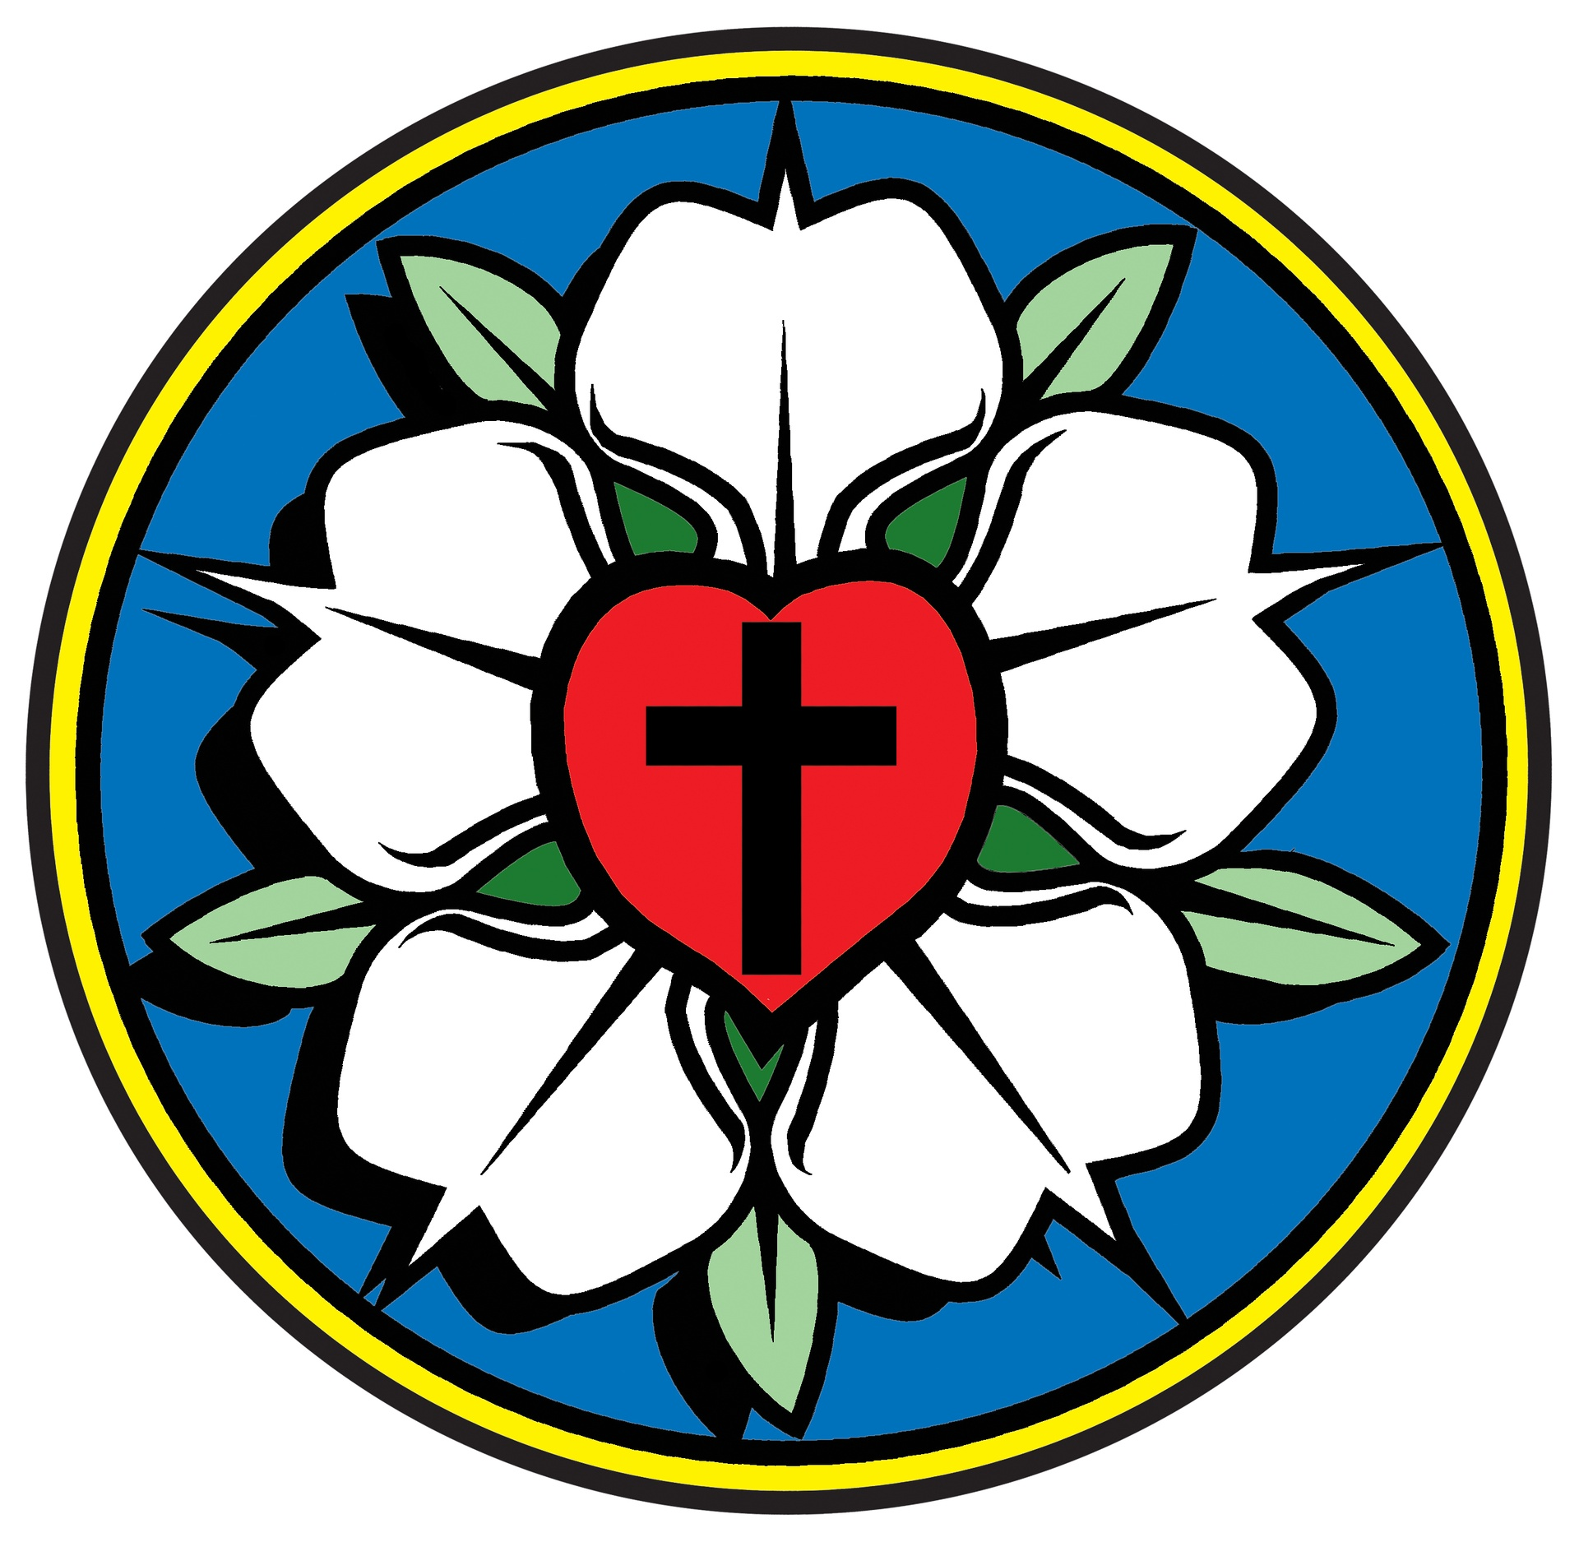
Reformation Lutheran Church
“Come and See, Learn and Rejoice, Go and Tell!”
July 2026

*********************************************************************************************************

“Come to me, all who labor and are heavy laden, and I will give you rest. Take my yoke upon you, and learn from me, for I am gentle and lowly in heart, and you will find rest for your souls.
For my yoke is easy, and my burden is light.”
- Matthew 11:28-30 -

Imagine horseback riding along a quiet country road lined with an over-growth of wildflowers or hiking endless trails atop mountains overlooking deep blue- and purple-colored canyons. Oh, the possibilities! Summer is a traditional time when most people plan their vacations to get away from their work; a time to rest and relax! The reality of escaping work for a while is that it will be there when you get back! In the text today, we are invited to a different kind of rest which goes beyond getting away for a little while.
We are personally invited with the words, “Come to me, all who labor and are heavy laden, and I will give you rest.” The phrase, “Come to me” is a very personal way to invite someone and yet, God uses them. How does this invitation make you feel? Our Lord wants us to recognize that he is always with us, so he asks us to come, rest, and intentionally be in his presence.
God’s invitation is a call to believe and a call to a committed fellowship with Christ. As disciples, we are continually being formed and shaped by the one who created us and calls us into service. But this can be tiring, even as it is exciting and wonderful. So, we are instructed by our Lord to, “Take my yoke upon you, and learn from me, for I am gentle and lowly in heart, and you will find rest for your souls.” As our faith in Christ and relationship with him grows, he will give us rest from our weariness and burdens.
How wonderful it is to know God loves us so much that he loves to be with us and hear from us. God also wants to show us how to have peace even in the midst of hardships or problems in this world. When we take rest in God’s presence and dwell there every day, we are transformed by his love and mercy. Christ will make us more Christ-like in our thoughts and actions. He will give us what we need for the day and that includes rest and restoration. When we rest in him, he restores our lives and teaches us how to live peacefully in a busy world that seeks to keep us moving and working and thinking all the time. Amen.

Pr.
**************************************************************************************************************
President’s Message: HAPPY BIRTHDAY, AMERICA! With everything being made of our 250th year, there have been many programs on TV outlining the discussions and final product of the Declaration of Independence. That group of men were among the most important and insightful group in the history of the world. I normally begin our council meetings with a prayer which begins by
thanking God that we are privileged to live in a country where we are free to worship as we
want and to partake of the sacraments. The fact that we can do this is attributable to those
men. Just this past week I read a survey taken in England which stated that only 5% of English citizens attend church regularly. That was a staggering statistic. The Lutheran Church has been in the United States and Georgia for a long time…see today’s history article. Even though the Lutheran Church has been in Georgia since 1733, we have not grown like some of the other denominations. Reformation is a special congregation. We are the little church with the big heart. We need to continue to reach out into the local community, show our willingness to give and encourage others in the area…churched or unchurched…that we are group that strives to make disciples.

Property: Clean-up day is scheduled for Saturday, July 25th. Helping hands are always welcome!

Education: Our Bible Study continues each Sunday at 9:30. Everyone is welcome!

Worship and Music: The new music program is up and running. So far, so good! I personally enjoy the Amen at the end of each hymn. Thanks again to Amy and Wayne for getting things going.

Fellowship: It has been a busy month of Fellowship with our Game Night on June 13th and then the Ladies provided treats for Father’s Day. Now, we are looking forward to a summer outing for our RLC Ladies. We will be meeting for lunch on Thursday, July 9, 11:00 a.m., at the Whistling Pig in Pine Mountain and then browse the shops along the main street afterward. I’m sure that fun will be had by all!😊

Mission and Ministry: Amy reapplied for our initial June outreach donation to Warrior Outreach Ranch, Fortson, to provide feed for their horses used for PTSD Therapy. But, for some reason, the Thrivent card request was rejected again. So, she is going to apply for a donation to be made to FOCUS Food Pantry to help with the increased need for food during the summer months when the public schools are not in session. Hopefully, this request will be approved!

Tammy has reached out and is waiting to hear from HC Sheriff’s Department for a date in August to host their Scam Prevention Presentation. She will let us know as soon as the date is confirmed.

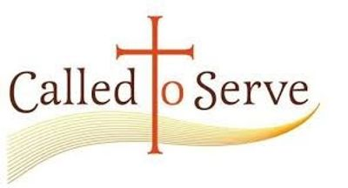
*************************************************************************************

July 5 July 12 July 19 July 25

Altar Guild Carolyn Amy Junior Tammy
Usher Junior Carolyn Amy Junior

Lector Chuck Wayne Tammy Gabi

Music Wayne Amy Amy Amy

Sermon Wayne Pastor Pastor Pastor

Bible Study (no study) Tammy Tammy Tammy

Thrive Wayne Wayne Gabi Gabi

Oaks Chuck Pastor Chuck Pastor


July
2nd – Tammy Jensen
10th – Stephanie Stephens
11th – Keith Owen
12th – Pastor Jon
23rd – Wayne Ramming



Saturday – July 4th – God Bless America! Land that I love! 250 YEARS!

Sunday – July 5th – NO Bible Study – 10:30 Service

Thursday – July 9th – Women to Pine Mtn. for lunch/shopping - 11:00 Whistling Pig

Sunday – July 12th - Bible Study – 9:30 in the fellowship hall 10:30 Service
Council following service
Thursday –July 16th – Lutheran Men – 11:30 – location TBD

Sunday – July 19th – Bible Study – 9:30 in the fellowship hall 10:30 service
Saturday – July 25th - clean-up day starting at 9:00

Sunday – July 26th – Bible Study – 9:30 in the fellowship hall 10:30 service

***************************************************************************

WE CONTINUE OUR STUDY OF LUTHERAN HISTORY WITH “New Sweden”
It was the smallest, least populated and shortest-lived colony in the US. But despite being virtually unheard of today, it helped shape the nation’s birth 250 years ago. Alamy Philadelphia is considered “The Birthplace of America” – but almost no one realizes the area was once Swedish.
Ask most Americans and they’ll tell you that the United States started in Philadelphia on 4 July 1776 when the Founding Fathers signed the Declaration of Independence. Fittingly, the city is the epicenter of the US’s 250th anniversary celebrations this week, and as many as 1.5 million people are expected to descend on it for what will be the nation’s largest Fourth of July festival.
But chances are, almost none of those coming realizes that the US’s political and ideological birthplace was once part of a little-known Swedish colony known as Nya Sverige (New Sweden).
In fact, very few Americans have any idea that there ever even was a Swedish colony in America.
From 1638-1655, this forgotten Swedish settlement extended across the Delaware Valley, encompassing parts of modern-day New Jersey, Pennsylvania, Delaware and Maryland. In addition to being the smallest, least populated and shortest-lived European colony in the US, it was also the most clandestine.
It started as sort of secret colony. The Swedes weren’t flag-planting like the French or the Spanish. The idea was to create an under-the-radar colony where the Dutch wouldn’t see them. Despite lasting just 17 years, New Sweden would play a pivotal role in forging the nation’s culture to come.
New Swedish settlers introduced the most iconic of American frontier buildings: the log cabin. They also brought Lutheran Christianity to the New World, led one of the earliest civilian uprisings in the US colonies and left their mark on two future US cities.
By 1637, European powers had already carved up much of the US’s Atlantic coast when Peter Minuit, the disgruntled former governor of the New Netherland colony, approached the Swedish Crown. Minuit had famously purchased the island of Manhattan for the Dutch and spent years scouting the Mid-Atlantic for a place to establish New Netherland. But after being abruptly dismissed in 1632, he sought revenge against his former employers.
To get back at the Dutch, Minuit went to Sweden and essentially said: you are the only major power in Europe without a colony and you’re missing out on the beaver and tobacco trade. I know where you can start one. With map in hand, Minuit showed Swedish officials that in between England’s claim to Virginia and New Netherland, there was a vast area unoccupied by Europeans. Minuit knew that even
though the Dutch claimed the entire Delaware River, they had only actually purchased one side of it along their southern border from the Lenape. He also knew that they were far more concerned with defending New Amsterdam (modern-day Manhattan) than the Delaware Valley.
So, in December 1637, Minuit led two ships out of Gothenburg with 25 would-be settlers to covertly cut in on the Dutch’s trade lucrative trade monopoly with the Native nations. After four months at sea, they quietly dropped anchor along a narrow, winding tributary of the Delaware River claimed by the Dutch in present-day Wilmington, hoping its secluded location wouldn’t
draw too much attention.
Despite its territorial expansion, New Sweden never became the profitable venture it was conceived to become because it was chronically under-populated and neglected. The colony never counted more than about 400 people, and from 1648-1654, the Swedish Crown didn’t send a single supply ship. Interest in emigrating was so low that the Swedish Empire resorted to sending petty criminals and military deserters as a form of punishment.
Just a short drive down Swedes Landing Road in Wilmington, there is an aptly named Old Swedes’ Church. Built in 1698, it holds the distinction of being both the first Lutheran church in the New World and the oldest church in the US still used for worship in its original state. This is a lost part of our history.
As an interesting addition to this story, Georgia also has a claim to the oldest Lutheran Church…Jerusalem Lutheran Church is the oldest continuous worshipping Lutheran Church in America.
Established in 1733, Jerusalem is located along the Savannah River near Rincon, GA in a settlement known as New Ebenezer. The first Sunday School in Georgia was held in 1734 and the first orphanage was built in 1737. The church was built from bricks made of clay from the area from 1767 to 1769. The walls of the church are 21 inches thick and some of the original panes of glass are still in the windows.
The bells were brought from Europe and are still rung before each service.

THIS IS MOST CERTAINLY TRUE

