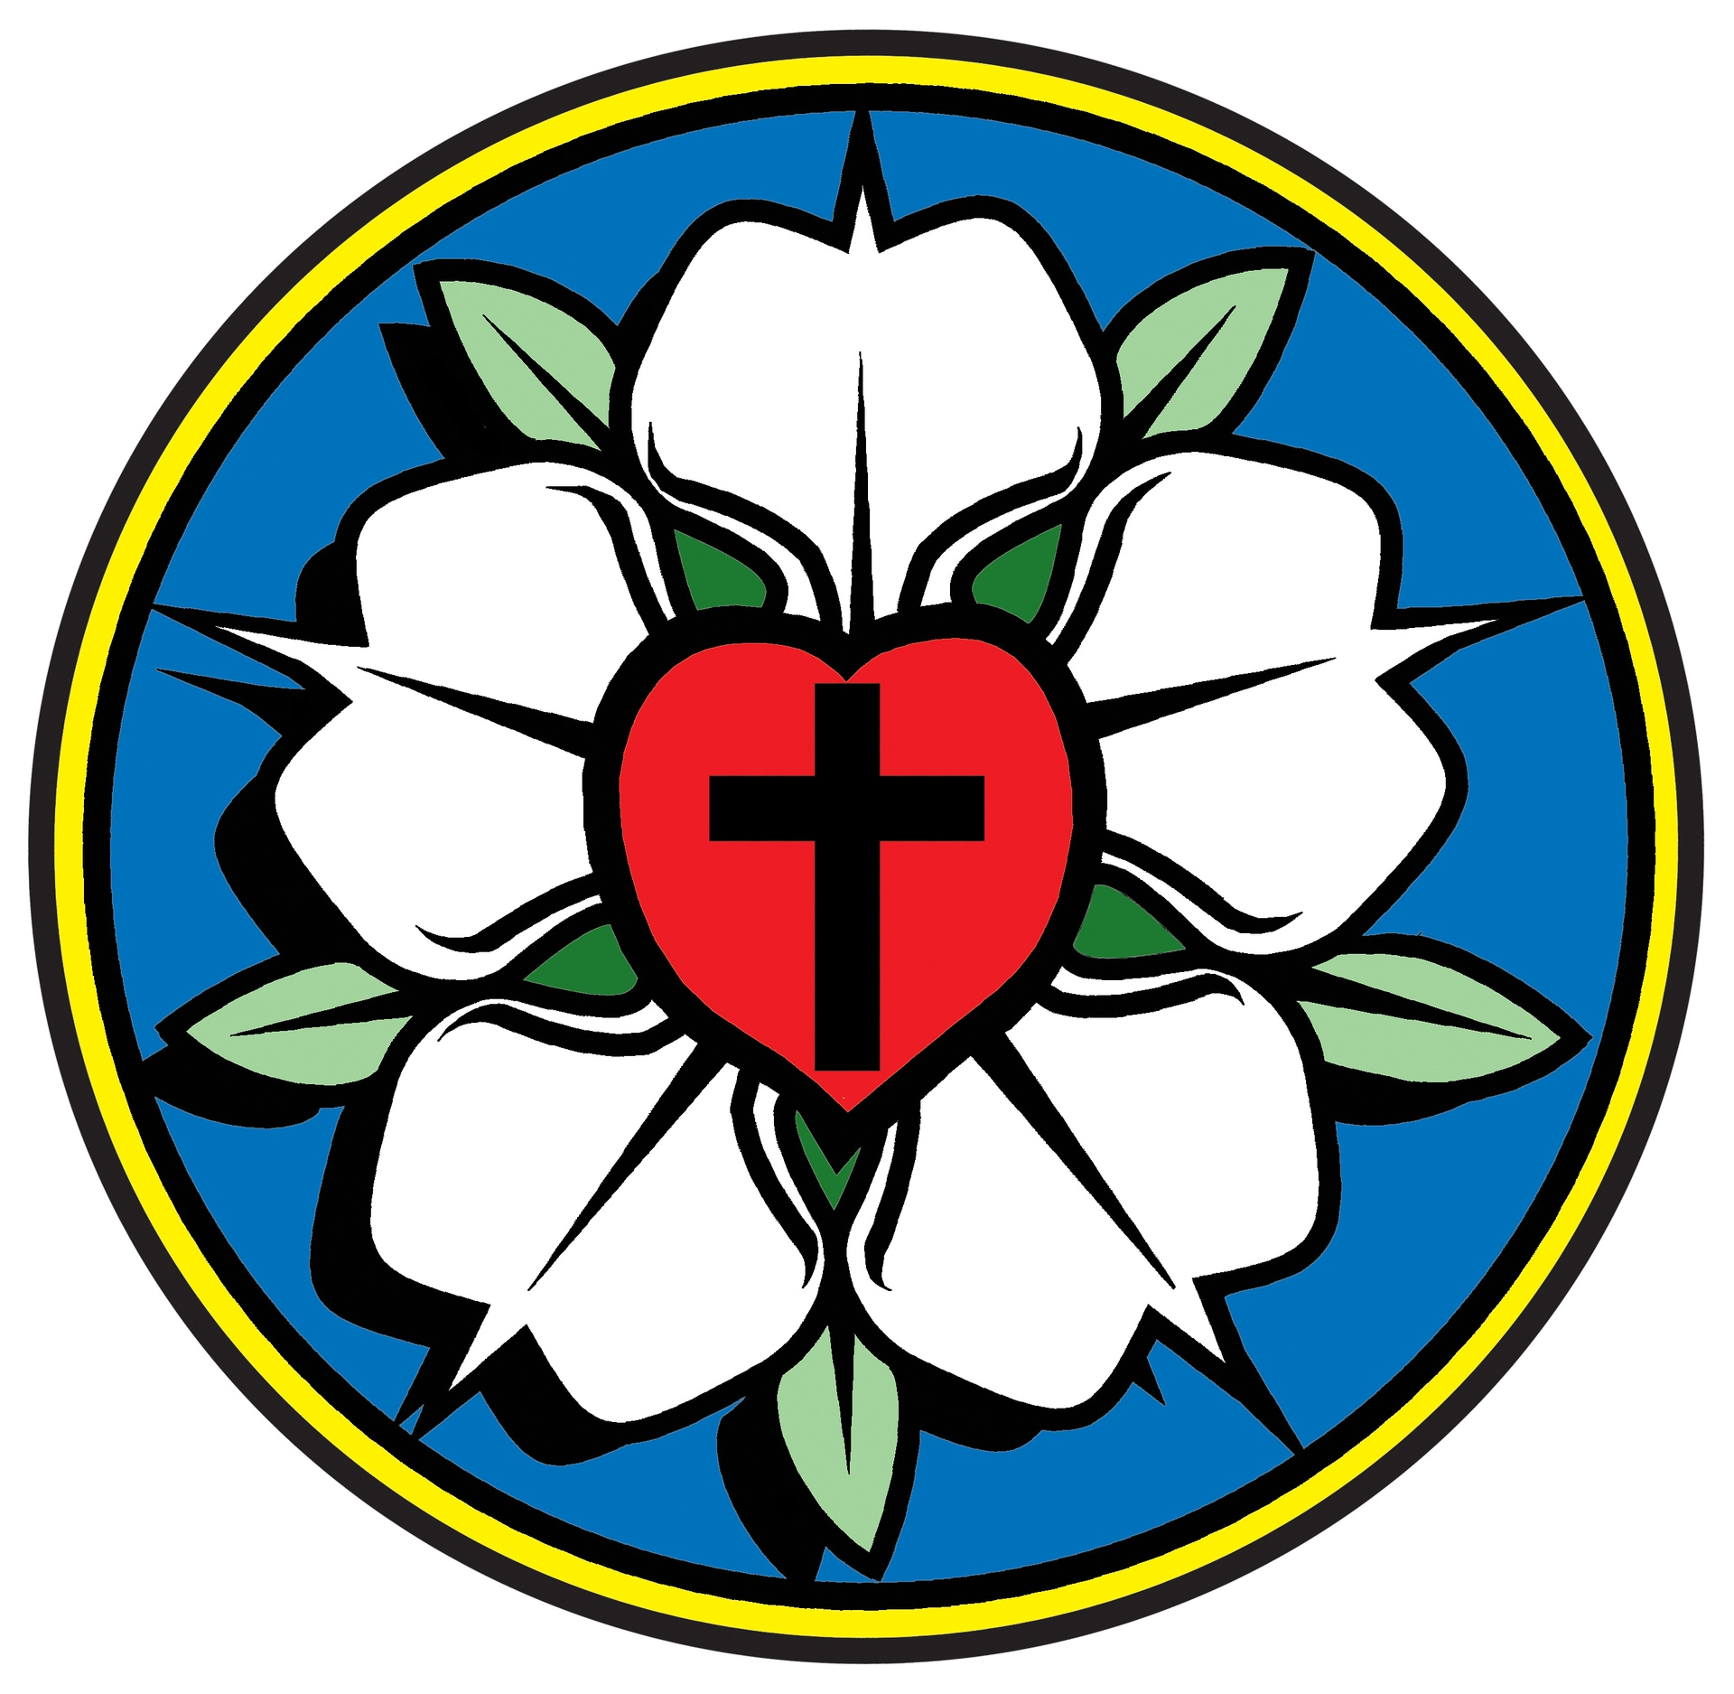
Reformation Lutheran Church
“Come and See, Learn and Rejoice, Go and Tell!”
February 2021

*********************************************************************************************************
“In the time of King Herod, after Jesus was born in Bethlehem of Judea, wise men from the East came to Jerusalem asking, ‘Where is the child who has been born king of the Jews? For we observed his star at its rising, and have come to pay him homage.’” - Matthew 2: 1-2
There are times when God shines a light into the murkiness of our lives and we miss it completely. There are times when God shines a light into the darkness of our days and we fail to give it the attention it deserves. The season of Epiphany began with wise men. Foreigners, unschooled in the faith of Israel or the promises made to Israel. What causes them to embark on their long and arduous journey across the desert? “We observed his star at its rising, and have come to pay him homage” they said. His star ... They look up and a brilliant light transfixes their gaze. Focused and determined, they pursue this light to the point where they recognize its significance more than those who really should know. It’s a revelation, a breakthrough. An Epiphany. They arrive in Jerusalem and what they already know, the religious scholars have to look up in their scrolls! References to a light. A birth. A king. A Savior. Amazing. He looks like the son of common peasants. Still, the wise ones kneel as they offer their finest gifts to the infant Jesus, believing that he is the Promised One who will be light and life for all people.
How little these magi know about Jesus, yet what a monumental effort they make to find Him! How little they know, yet what costly gifts they bring! “We have come to pay him homage.” In its purest form, worship is a celebration of Jesus - the Light of Life, who alone dispels the darkness of our world and of our own hearts. When we sing “this is the feast,” we’re saying that worship is a victory party. But we need to understand that while we share the victory, it’s not our party. Too many Christians judge worship by what they get out of it. “It didn’t touch me. The hymns were unfamiliar. The sermon was too long. The acolytes were fidgety.” You can’t honor God with a consumer mentality. The true measure of worship is not how many people showed up or how much you liked it. The true measure of worship is, “What did you put into it?” Did you put into it your ears, your heart, yes, even your faith? And “Was the Lord pleased?” We have come to pay him homage... to seek the light that has first sought us. Amen.
Pr.
**************************************************************************************************************
“February days are a marketing gimmick; love happens every day.” Author Unknown
I think Christmas hadn’t been too far gone when I started seeing Valentine’s Day stuff in the stores. Sigh. I get it. Make sure your loved one knows how much you love them. Etc. etc. etc. Love does
happen every day though. It’s the little things. Think about it. Making coffee for your spouse. Running out to the store for medicine when they don’t feel well. A quick text during the day. Simply
sharing day to day life. Not necessarily the stuff of Hallmark movies, but comforting and reliable. God’s love happens every day as well, but it is so much more than “the little things.” Every day, He is willing to forgive us for our wrongs. Every day, He is our comfort and strength. Every day, He is there for all our needs/concerns/joys/praise. Every day, His love covers us and blesses us. That’s better than a box of chocolate and flowers any day!

Peace be with you, Gabi

Treasurer’s Report: We're off to a great start this year thanks to our members keeping up with their tithes and an extremely generous ($25,000) contribution from the Aldermans. The good Lord is looking out for our congregation! God bless all of you!

Fellowship: As seems to be the way with us lately, our fellowship will revolve around food! There is a sign up sheet in the fellowship hall for our Lenten meals. Any contributions will be welcomed.

Property: Our February clean up day will be Saturday, the 27th.

Education – Our in person Bible study will resume at some point in life. 😊 Thanks to Chuck for sending our regular email studies.
Worship and Music: We looked forward to 2021…it’s here…not a lot has changed. Sunday services continue each week with social distancing and mask wearing as the rules. We continue to send the service and Pastor Jon’s audio sermons to everyone who doesn’t make the Sunday morning service. Let me know if there is someone you feel would like to receive our Sunday service, and I will gladly add them to the distribution list.
We are fast approaching the Lenten season. We will have Wednesday Lenten services, and as in the past, we will have food at 6:00 with the service following at 7:00. We did this during Advent and it worked well. There is a sign-up sheet in the Fellowship Hall if you would like to bring the food for a Wednesday evening.
We have just finished reviewing the Sacrament of the Alter in our Monday devotion. Beginning February 8, we will finish reviewing the Small Catechism and then begin looking at our liturgy.

Mission and Ministry: We have another Thrivent Project under our belts! We were able to supply students in a local Title 1 school with needed supplies. We have many more opportunities to apply for project cards. If you know of a need or have ideas, please let us know!

*************************************************************************************
February 17th – Seth Armstrong
February 26th – Karen Washington

**********************************************************************
"Every gardener knows that under the cloak of winter lies a miracle ... a seed waiting to sprout, a bulb opening to the light, a bud straining to unfurl. And the anticipation nurtures our dream."
Barbara Winkler

Sunday – February 7th – executive council

Sunday – February 14th – Annual Meeting/council

Wednesday – February 17th – Ash Wednesday service – 7:00

Wednesday – February 24th – Lenten Meal 6:00 Service 7:00
Saturday – February 27th– clean up day starting at 9:00

*****************************************************************************************************************

Feb. 7 Feb. 14 Feb. 21 Feb. 28

Altar Guild Wayne Junior Carolyn Judy

Comm. Asst. none needed as we are currently using intinction during communion
Usher Junior Judy Wayne Carolyn

Lector Lynne Junior Karen Gabi

Sermon Pastor Pastor Chuck Pastor

***********************************************************************************

WE CONTINUE OUR STUDY OF LUTHERAN HISTORY WITH Slovak Lutherans: A Tough-minded People
Lutheranism in Europe fared the best in those countries where it was a majority, supported by the government-such as in Scandinavia, the Baltic, and parts of Germany. But the shifting fortunes of religion and politics sometimes stranded Lutheran Christians in areas where they became the religious minority among other Christians.
This was a difficult thing for these Lutherans, who often faced neglect and persecution from the majorities around them and who had to struggle to maintain their distinct Lutheran identities. Such was (and is) the case of the Lutherans in the central European country of Slovakia, where centuries of being in the minority have challenged but not destroyed the Lutheran community there.
Movements for reform of the medieval Catholic church took hold in Slovakia in the fifteenth century, 100 years before Martin Luther, through the efforts of reformer Jan Hus and organized groups such as the Hussites and later the Bohemian Brethren.
Lutheranism came into Slovakia in the early sixteenth century and was quickly embraced by a good portion of the people, though it was fiercely opposed by the local medieval Catholic hierarchy, with the strong support of the Hungarians rulers of Slovakia. The Roman Catholic attempts to wipe out Protestantism in Slovakia (and elsewhere), called the counter-Reformation, reached their peak in the seventeenth century, when hundreds of Czech Slovak Lutheran pastors were tortured, imprisoned, exiled, and even sold into slavery. The Lutheran churches and population in Slovakia came under tremendous pressure, and many had to go underground to survive. A measure of relief came in the eighteenth century when enlightened rulers came to the throne of the Austro-Hungarian empire, but the Lutherans in Slovakia had suffered greatly, and it took a long time for them to recover.
Slovak Lutherans were, however, a stubborn (and even tough) people, and they withstood these centuries of persecution because of their deep commitment to the Lutheran understanding of the Christian faith. The Bible was translated into the local languages in the early sixteenth century, and groups of local cities issued Lutheran confessions of faith, but it was above all their hymns and hymnals that formed the core of their faith, and that held them together during the tough times. Above all was the work of Pastor Jiff Tfanovsky (1592-1637), who translated the Augsburg Confession into Slovak and produced the hymnal, Cithara Sanctorum, which has formed the bedrock of Slovak Lutheranism over the centuries. Two hymns from this hymnal are found in Evangelical Lutheran Worship,"Your Heart, 0 God, Is Grieved" (hymn 602) and "God, my Lord, My Strength" (hymn 795).
Slovaks began immigrating to the United States around the turn of the twentieth century, settling mainly in mining and industrial areas stretching from Pennsylvania to Wisconsin. The majority of Slovak immigrants were Roman Catholic, but a sizable minority of Slovak Lutherans also came. It is hard to know how many Lutheran Slovaks immigrated, because they were lumped together with other ethnic groups, but a rough estimate of Slovak Lutherans in 1960 totaled over 40,000 baptized members in 104 congregations. A substantial number of immigrants came to the United States before and after World War I, and ministry in the Slovak language regularly occurred in these congregations though the 1980s.
Slovak-American Lutherans formed their first organization in 1902, the Slovak Evangelical Lutheran Church (SELC), which affiliated with the Synodical Conference (dominated by the Lutheran Church-Missouri Synod). As a result of internal tensions within the Slovak Lutheran community, about half the Slovaks left the SELC and formed the Slovak Zion Synod in 1918. The Slovak Zion Synod joined with the eastern United Lutheran Church in America in 1920, becoming a non-geographical, ethnic synod within the ULCA, later the LCA, and now in the ELCA. The Slovak Evangelical Lutheran Church changed its name to the Synod of Evangelical Lutheran Churches in 1959, and in 1971 it became a non-geographical district of the Lutheran Church-Missouri Synod, which also remains today. The Slovak Lutheran habit of independence is hard to overcome, and both the SELC and the Slovak Zion Synods maintain a measure of their own autonomy. One of the most Significant Slovak-American Lutherans was Dr. Jaroslav Pelikan, a distinguished theologian and historian.
After World War II, Slovakia was plunged into Communist rule for forty years, its state-atheism again challenging the Slovak Lutherans. Much damage was done to the Lutheran churches in Slovakia during this time, but, since the end of Communism, American Lutherans (Slovaks and others) have worked hard to help rebuild the Slovak Lutheran communities in a newly independent Slovakia. Both the LCMS and the ELCA have sent teachers and assistance to the Slovak Lutherans, and many local congregations have helped in these efforts. Slovak Lutherans are, in many ways, survivors, and 500 years of history and tradition suggest that they will once again rebuild their Lutheran communities.

“THIS IS MOST CERTAINLY TRUE”

